Snowflake Architecture & Cache with Practical Examples

1. Explain in your own words the three main layers of Snowflake architecture.
Practical:
Draw a simple diagram showing Storage, Compute (Virtual Warehouse), and Cloud Services.
Explain what happens when you run a SELECT query.

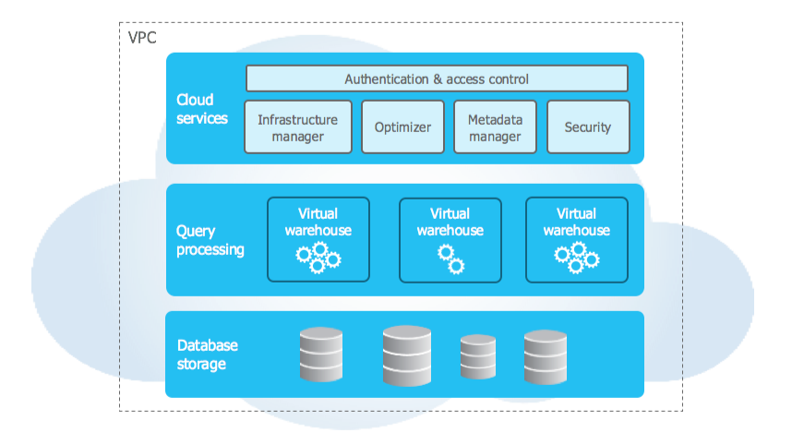

1.Storage Layer – Where data is stored
The Storage layer is where all data is saved permanently.
What it does
Stores tables and data
Uses cloud storage (AWS / Azure / GCP)
Automatically:
Compresses data
Encrypts data
Manages micro-partitions
2.Compute Layer (Virtual Warehouse) – Where queries run
The Compute layer runs SQL queries using Virtual Warehouses.
What it does
Executes:
SELECT
INSERT / UPDATE / DELETE

3.Cloud Services Layer – The brain
The Cloud Services layer manages everything automatically.
What it does
Authentication & access control
Query parsing & optimization
Metadata management
Transaction control

What Happens When You Run a SELECT Query?
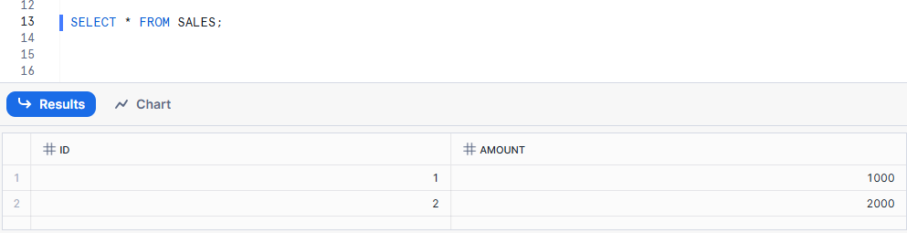

Step-by-Step Execution
1.Query goes to Cloud Services
2.Query is optimized
3.Virtual Warehouse starts
4.Data is read from Storage
5.Query executes
6.Results returned

2. What is the role of the Storage layer in Snowflake?
The Storage layer in Snowflake securely stores all data independently of compute, ensuring data persists even when virtual warehouses are suspended.
Suspended :- Virtual Warehouse is stopped (paused) and not using any compute resources.
Practical:
Create a table and insert some data. Show how data remains stored even if the warehouse is suspended.
Create a table
CREATE OR REPLACE TABLE STUDENTS (
ID INT,
NAME STRING,
MARKS NUMBER
);

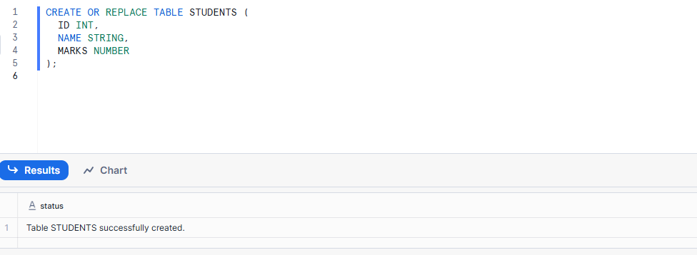
Insert Data
INSERT INTO STUDENTS VALUES
(1, 'Ravi', 80),
(2, 'Sita', 90),
(3, 'Kiran', 85);
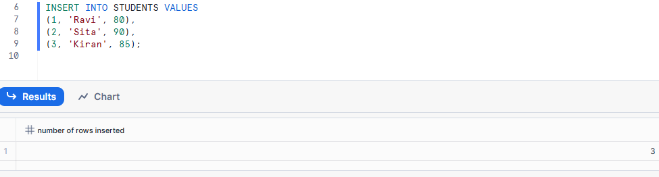
Select Query
SELECT * FROM STUDENTS;
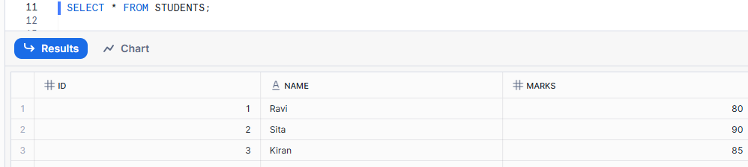
Suspend the warehouse
ALTER WAREHOUSE COMPUTE_WH SUSPEND;

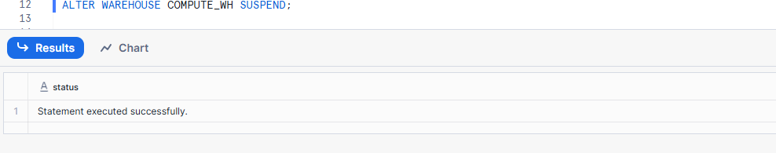
Warehouse is OFF
Data is still stored

Resume warehouse and query again
ALTER WAREHOUSE COMPUTE_WH RESUME;
SELECT * FROM STUDENTS;
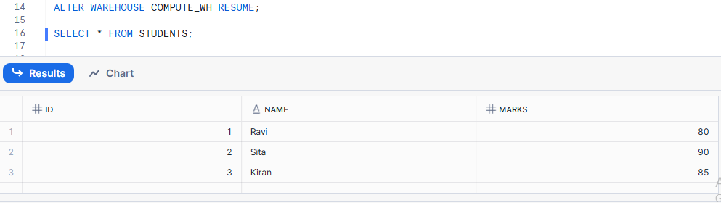

3. Describe what a Virtual Warehouse is in Snowflake.
A Virtual Warehouse is the compute engine in Snowflake that runs SQL queries.
Practical:
Create a warehouse, run a query, then suspend the warehouse. Show how warehouse size affects query speed by resizing it.
Create a Virtual Warehouse
CREATE OR REPLACE WAREHOUSE DEMO_WH
WITH
WAREHOUSE_SIZE = 'SMALL'
AUTO_SUSPEND = 60
AUTO_RESUME = TRUE;

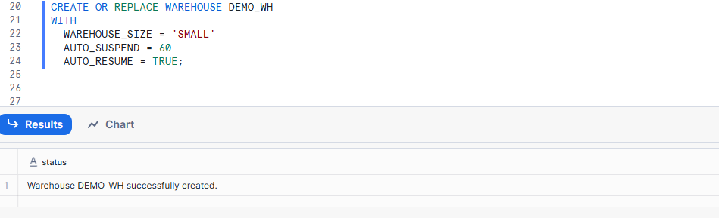
Use the warehouse
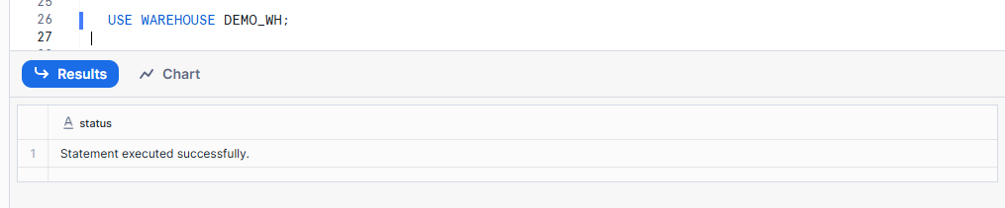
Run a query
SELECT COUNT(*) FROM STUDENTS;
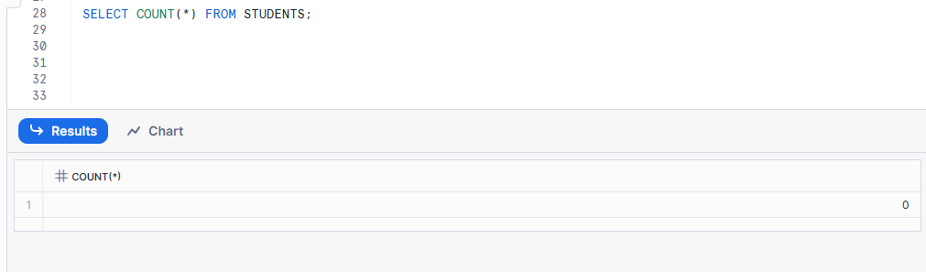

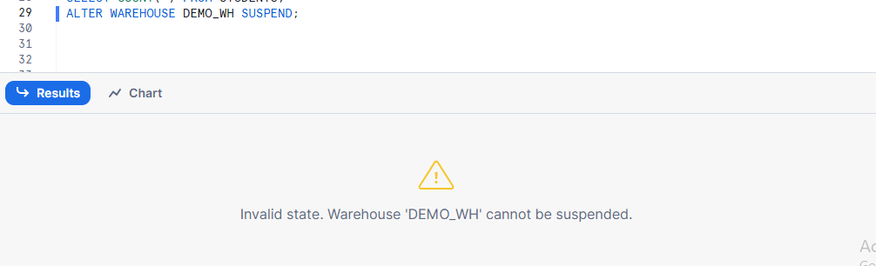
Resize warehouse (Speed comparison)
Resize to MEDIUM
ALTER WAREHOUSE DEMO_WH SET WAREHOUSE_SIZE = 'MEDIUM';
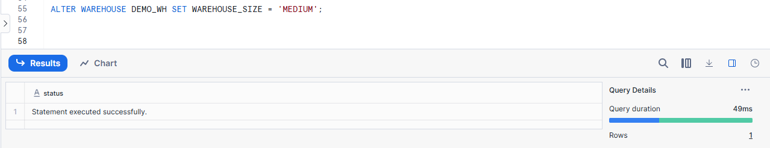
Run query again:
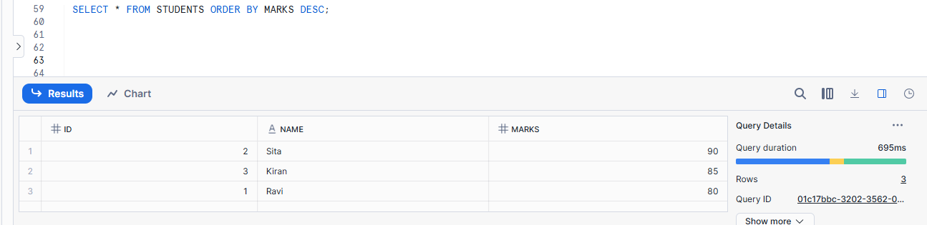
Runs faster than SMALL
Resize to LARGE
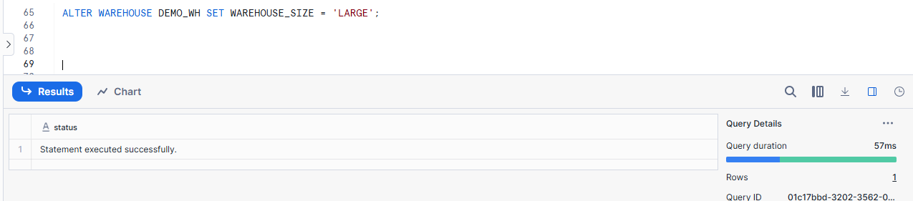
Run same query:
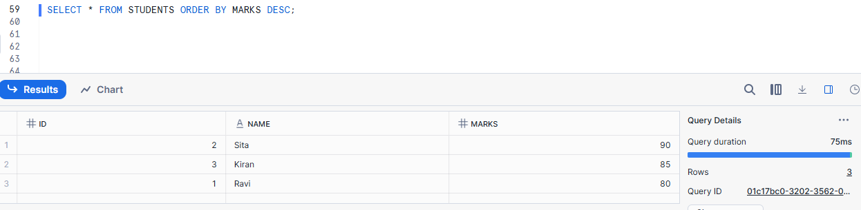

4. Explain micro-partitions and their importance.
Micro-partitions are small data blocks that Snowflake automatically creates when data is stored.
Practical:
Run a query with a filter (e.g., WHERE AMOUNT > 1000) and explain how Snowflake reads only relevant micro-partitions to speed up the query.
Create a table
CREATE OR REPLACE TABLE SALES (
ID INT,
AMOUNT NUMBER
);
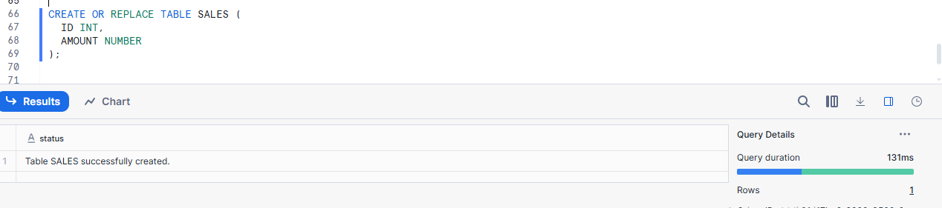
Insert Data
INSERT INTO SALES VALUES
(1, 500),
(2, 800),
(3, 1200),
(4, 2000),
(5, 3000);
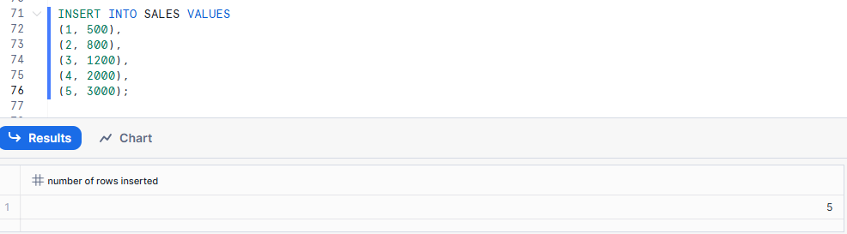
Run a filtered query
SELECT *
FROM SALES
WHERE AMOUNT > 1000;
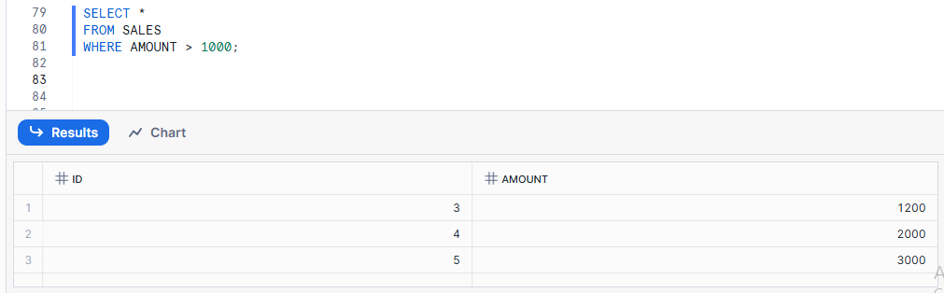
What happens internally (Step-by-Step)
1.Query reaches Cloud Services
2. Metadata is checked
3. Micro-partition pruning
4. Compute reads only relevant data
5. Results returned

5. What is the Cloud Services layer?
The Cloud Services layer is the brain of Snowflake that manages security, users, roles, metadata, and query planning
Practical:
Show a login process and role-based access in Snowflake. Explain how Cloud Services verify permissions before query execution.
Create Analyst role
CREATE OR REPLACE ROLE ANALYST_ROLE;
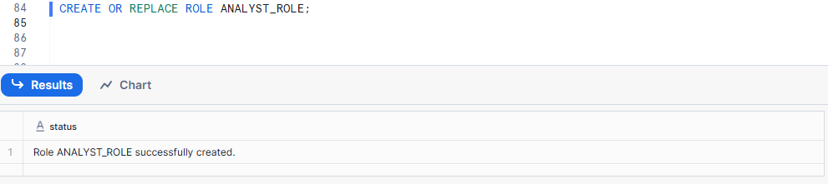
Check existing roles
SHOW ROLES LIKE 'ANALYST_ROLE';
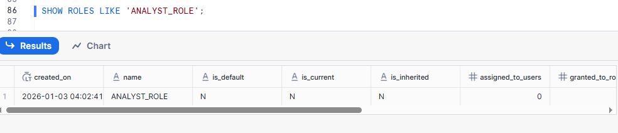
Skip role creation and continue with grants
GRANT USAGE ON WAREHOUSE DEMO_WH TO ROLE ANALYST_ROLE;
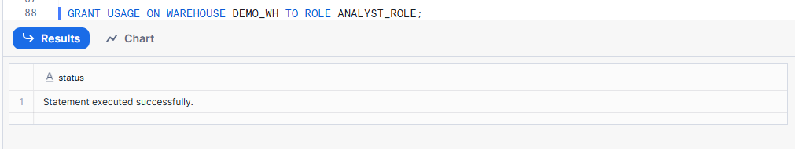
GRANT USAGE ON DATABASE TRAINING_DB TO ROLE ANALYST_ROLE;
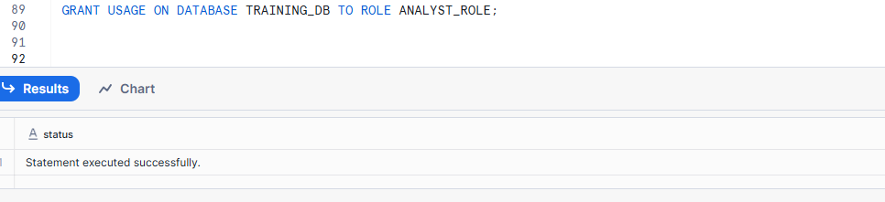
GRANT USAGE ON SCHEMA TRAINING_DB.SALES_SCHEMA TO ROLE ANALYST_ROLE;
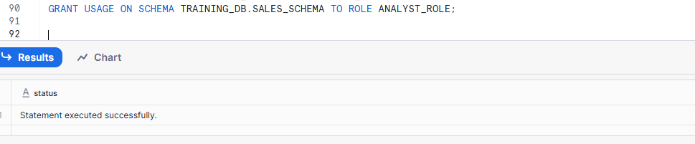
GRANT SELECT ON TABLE TRAINING_DB.SALES_SCHEMA.SALES TO ROLE ANALYST_ROLE;
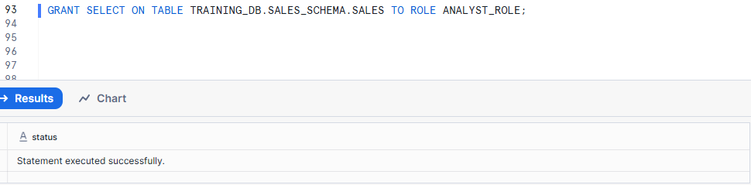

6. Name and describe the three types of cache Snowflake uses.
Cache means temporary memory that avoids doing the same work again.
Three types of Cache there are
1.Result Cache
2.Local Disk Cache
3. Metadata Cache
Practical:
Run the same query twice and measure execution time to demonstrate Result Cache.
Restart warehouse and rerun query to explain Local Disk Cache.
1.Result Cache:- Result Cache stores the final output of a query.
No warehouse compute is used
Fastest cache
Valid for 24 hours
Used only if:
Same query
Same data (no changes)
Same role

Run query first time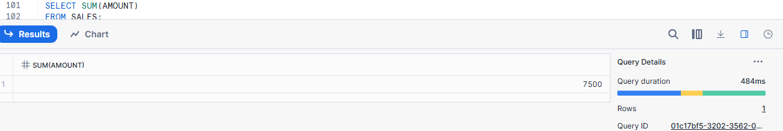
SELECT SUM(AMOUNT)
FROM SALES;

Run the SAME query again
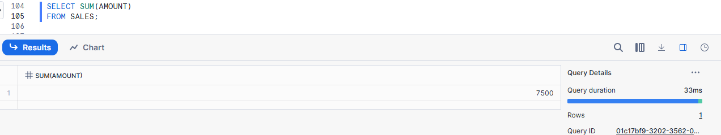
First time run the query it takes time:-484ms
Second time run the same query it takes time:- 33ms
2.Local Disk Cache
Stores frequently accessed data on the warehouse’s local disk.
- Used when result cache is NOT applicable
- Data is reused across queries
- Faster than reading from storage
- Exists only while warehouse is running
Run query
SELECT *
FROM SALES
WHERE AMOUNT > 1000;

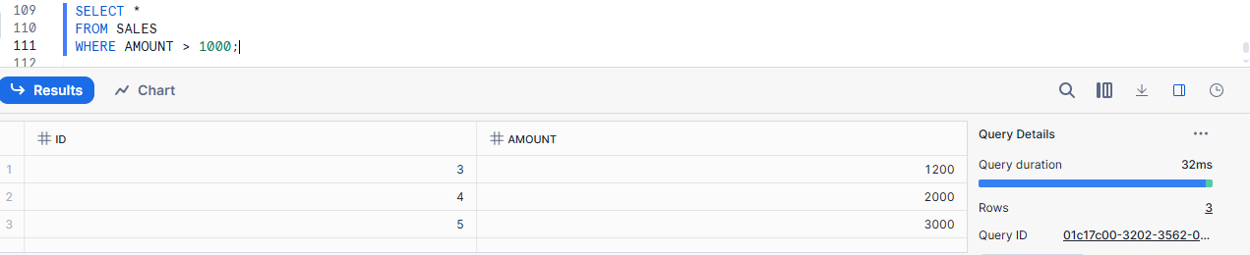
Run a similar query
SELECT COUNT(*)
FROM SALES
WHERE AMOUNT > 1000;
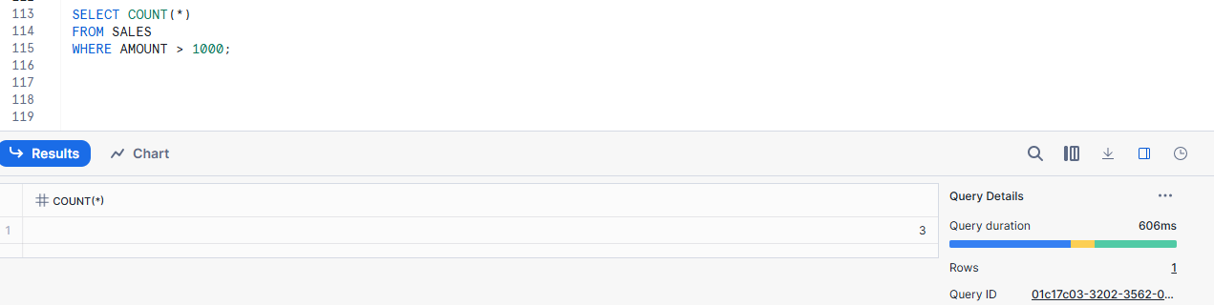
Suspend and resume warehouse
ALTER WAREHOUSE DEMO_WH SUSPEND;
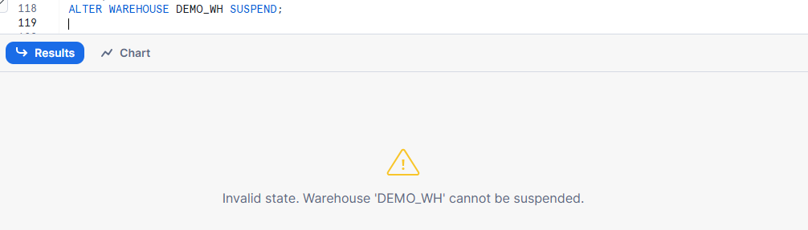
ALTER WAREHOUSE DEMO_WH RESUME;
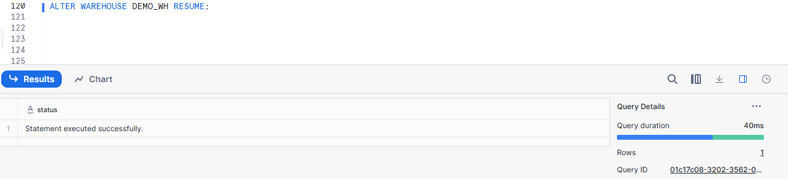
Run query again
SELECT *
FROM SALES
WHERE AMOUNT > 1000;
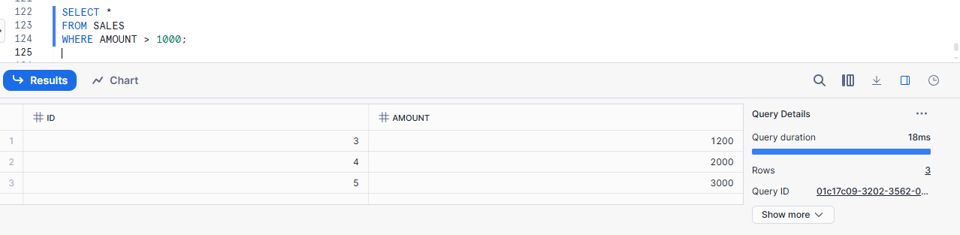
3.Metadata Cache
Stores information about data, not the data itself.
Includes:
- Table structure
- Column types
- Micro-partition min/max values
Used by:
- Query optimizer
- Micro-partition pruning
SELECT *
FROM SALES
WHERE AMOUNT > 1000;

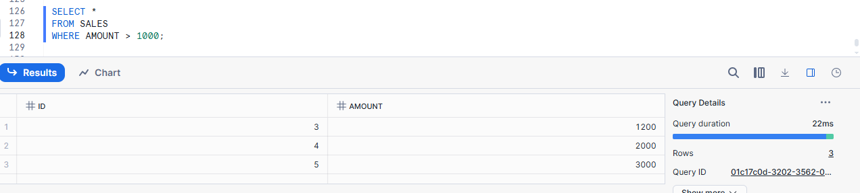

7. Explain Result Cache.
Practical:
Run a COUNT(*) query twice and note that the second run doesn’t consume compute resources.

Result Cache stores the final result of a query so that when the same query is run again, Snowflake returns the result instantly without using compute.
No warehouse compute is used
Fastest cache
Valid for 24 hours
Used only if:
Same query
Same data (no changes)
Same role
Run COUNT(*) query (First time)
SELECT COUNT(*) FROM SALES;
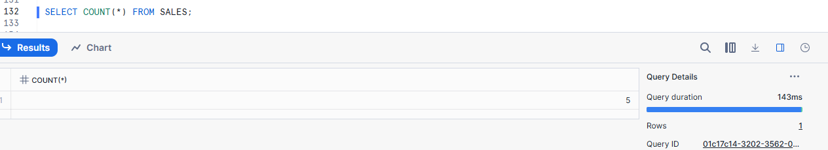
What happens:
Warehouse runs
Data is scanned
compute is used
Result is stored in Result Cache
Run the SAME query again
SELECT COUNT(*) FROM SALES
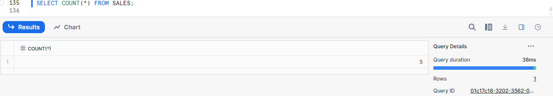
What happens now:
Result returned from Result Cache
No warehouse compute
Query finishes almost instantly

8. How does Local Disk Cache differ from Result Cache?
Practical:
Run a query, suspend warehouse, restart it, run the query again, and observe performance change.

Result Cache:-
Result Cache stores the final result of a query and returns it instantly when the same query is run again.
No warehouse needed
No compute used
Fastest cache

Local Disk Cache (Warehouse Cache):-
Local Disk Cache stores table data on the warehouse’s local disk while the warehouse is running.
Warehouse required
Compute is used
Faster than reading from storage
Cache is cleared when warehouse is suspended
Run a query (First time)
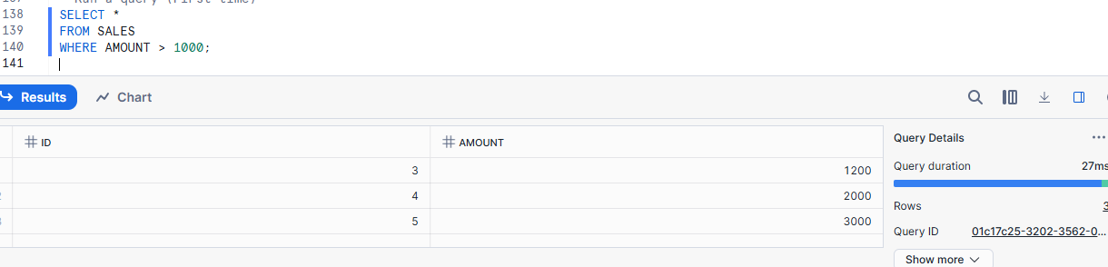
What happens:
Warehouse runs
Data read from Storage
Data stored in Local Disk Cache
Query takes more time

Run the SAME query again

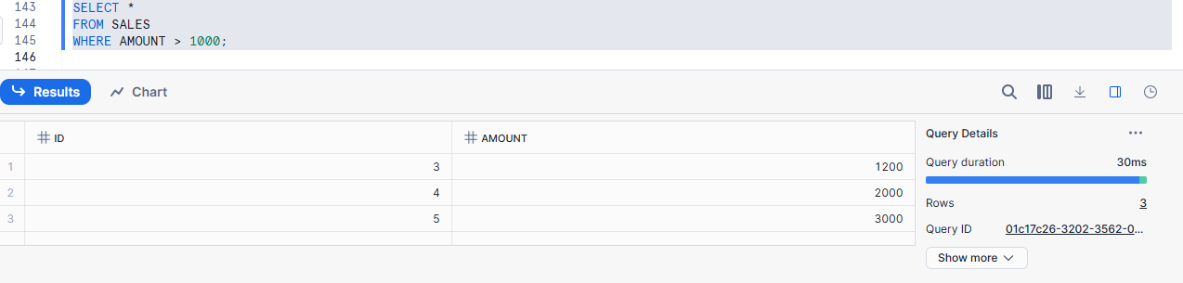
Suspend the warehouse
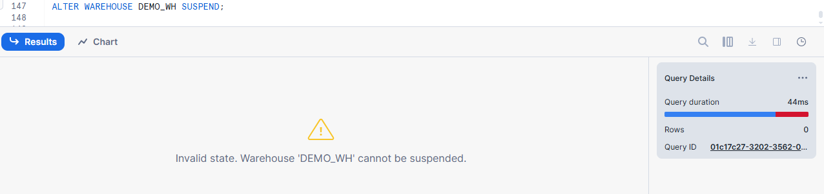
Resume warehouse
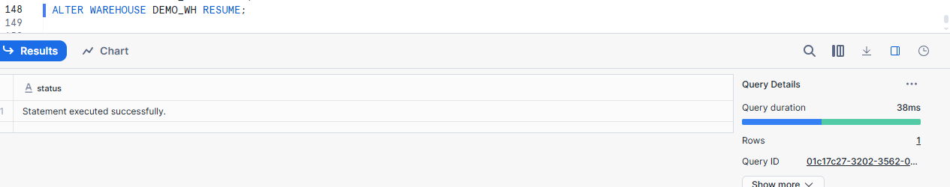
Run the query again
SELECT *
FROM SALES
WHERE AMOUNT > 1000;

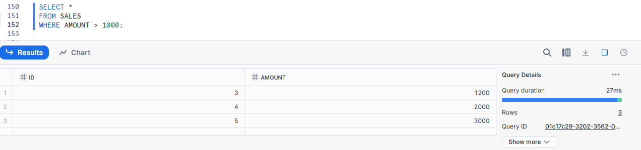

9. What happens to caches when table data changes?
Practical:
Run a query twice, insert new rows, run again and explain why the Result Cache is invalidated and query runs fresh.
When table data changes in Snowflake, the Result Cache is cleared (invalidated) so that queries run again and return fresh, correct data instead of old results.
Run a query (first time)
SELECT COUNT(*) FROM SALES;
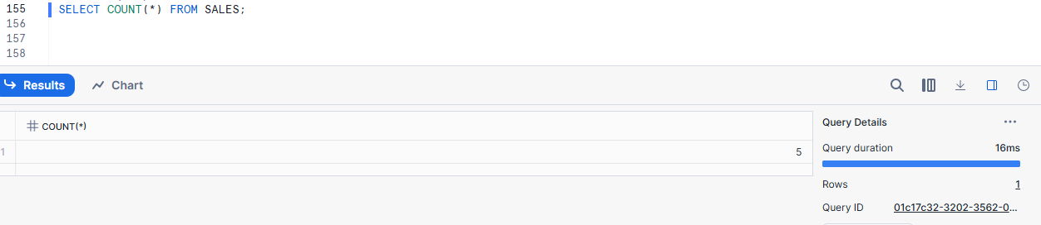
Warehouse runs
Result is calculated
Result stored in Result Cache
Run the same query again
SELECT COUNT(*) FROM SALES;
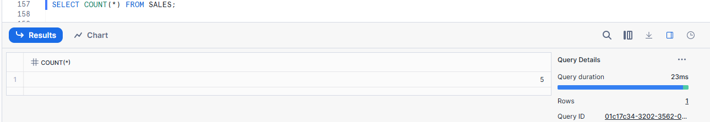
Result returned from Result Cache
Very fast
No compute used
Insert new data
INSERT INTO SALES VALUES (6, 5000);
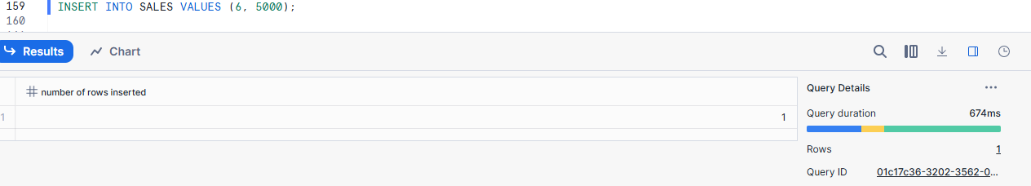
Table data is changed
Run the query again
SELECT COUNT(*) FROM SALES;
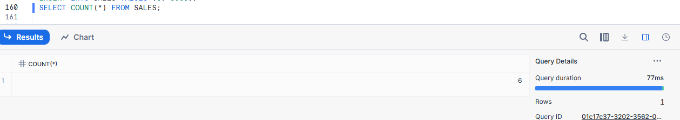

Result Cache is invalidated
Snowflake runs query again
Compute is used
New correct result returned

10. Describe the difference between first and second run of the same query.
Practical:
Run a query once (full compute), then immediately run again (Result Cache), and explain the difference in resource usage.
The first run of a query uses compute resources to read data and calculate results, while the second run of the same query returns results from Result Cache without using compute.
First run (Full compute used)
SELECT COUNT(*) FROM SALES;
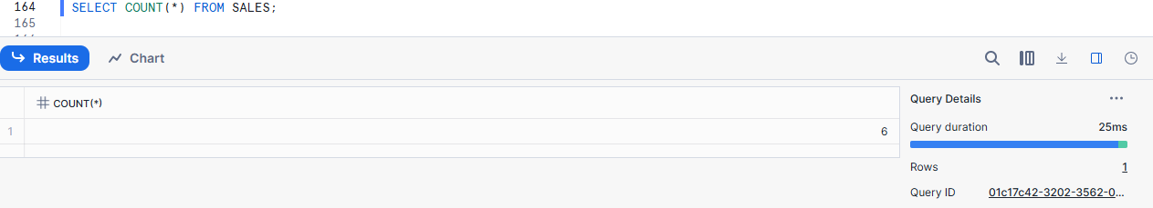
Second run (Result Cache used)
SELECT COUNT(*) FROM SALES;

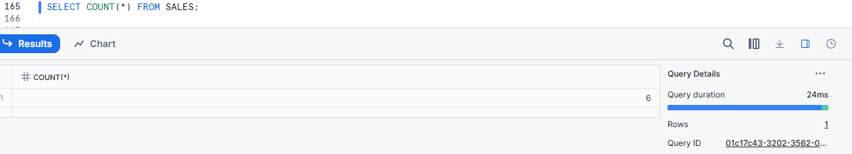

11. How does Snowflake’s compute scaling work?
Practical:
Run a complex query on a small warehouse, then increase warehouse size and rerun the query, observing improved speed.
Snowflake compute scaling means you can increase or decrease the size of a virtual warehouse to control query speed and performance without changing the data.
Run a complex query on SMALL warehouse
ALTER WAREHOUSE DEMO_WH SET WAREHOUSE_SIZE = 'SMALL';
SELECT *
FROM SALES
ORDER BY AMOUNT DESC;
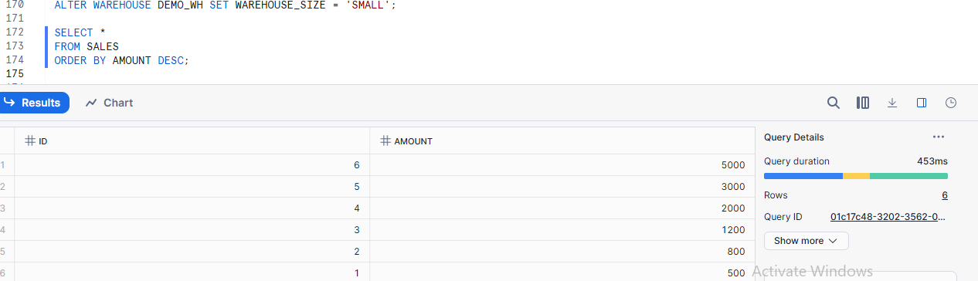
Increase warehouse size
ALTER WAREHOUSE DEMO_WH SET WAREHOUSE_SIZE = 'LARGE';
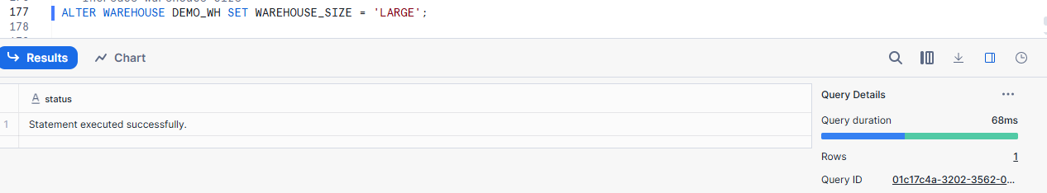
Run the SAME query again
SELECT *
FROM SALES
ORDER BY AMOUNT DESC;
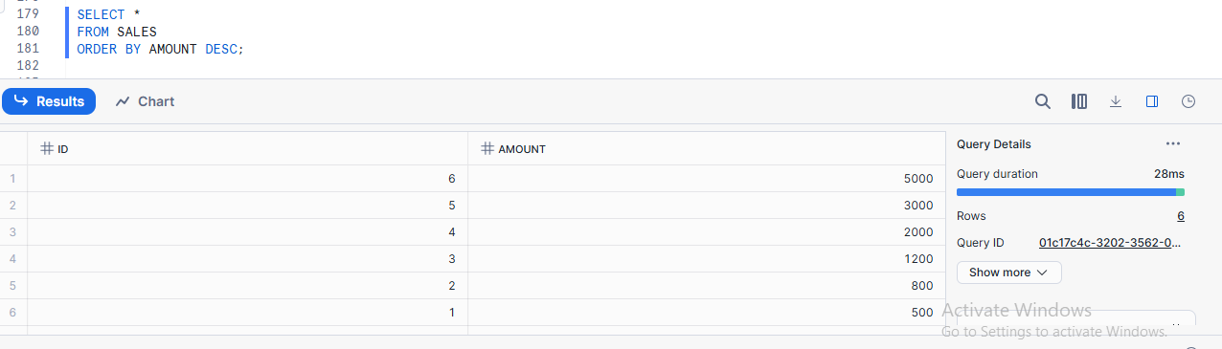

12. Explain external stage vs internal stage.
Practical:
Create an internal stage and upload a file. Create an external stage pointing to S3 and explain the differences.
Internal Stage:-
An internal stage stores files inside Snowflake.
Key points:
Files are stored in Snowflake storage
No cloud account (S3/Azure/GCS) needed
Best for small files, testing, demos

External Stage:-
An external stage points to files outside Snowflake (like AWS S3).
Key points:
Files stay in S3 (data does not move)
Uses IAM Role / Storage Integration
Best for large, production data
Create Storage Integration
CREATE STORAGE INTEGRATION my_s3_integeration
TYPE = EXTERNAL_STAGE
STORAGE_PROVIDER = S3
ENABLED = TRUE
STORAGE_AWS_ROLE_ARN = 'arn:aws:iam::939446055421:role/s3_storage'
STORAGE_ALLOWED_LOCATIONS =('s3://shilpas3-2025/emp/');

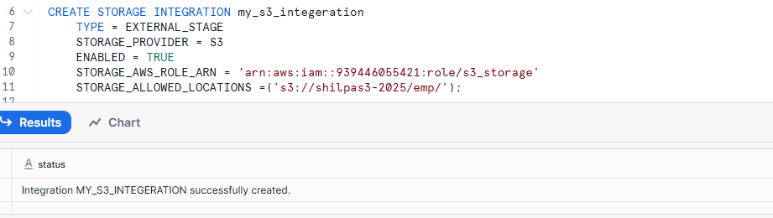
Create Raw stage pointing to S3
CREATE OR REPLACE STAGE raw_stage
URL = 's3://shilpas3-2025/emp/'
storage_integration=my_s3_integeration
FILE_FORMAT =(
TYPE = 'CSV',
FIELD_DELIMITER = ',',
SKIP_HEADER = 1
);

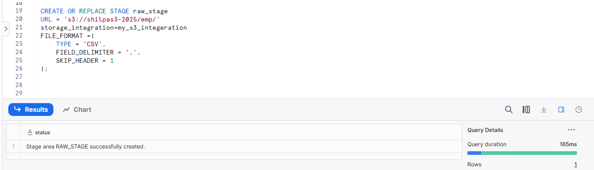
Check files in external stage
list @raw_stage;
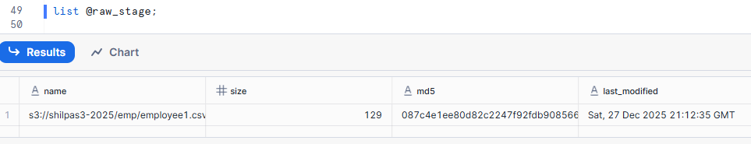

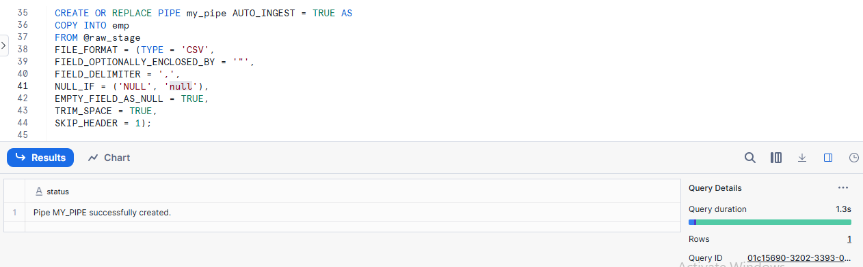

13. Explain the statement:
“Data never moves, compute comes and goes.”
Practical:
Show data stored in table remains the same regardless of warehouse start/stop and resizing.

In Snowflake, data is stored permanently, but compute (warehouse) can be started, stopped, or resized anytime without affecting the data.

Break into two parts
1.Data never moves
2.Compute comes and goes
1.Data never moves
Data is stored in the Storage layer
It stays safe even if the warehouse is stopped
Data does not depend on comput
2.Compute comes and goes
Compute = Virtual Warehouse
Warehouses can be:
Started
Stopped (suspended)
Resized (Small → Large)
Compute is used only to run querie
Create a table
CREATE OR REPLACE TABLE PRODUCTS (
ID INT,
NAME STRING,
PRICE NUMBER
);
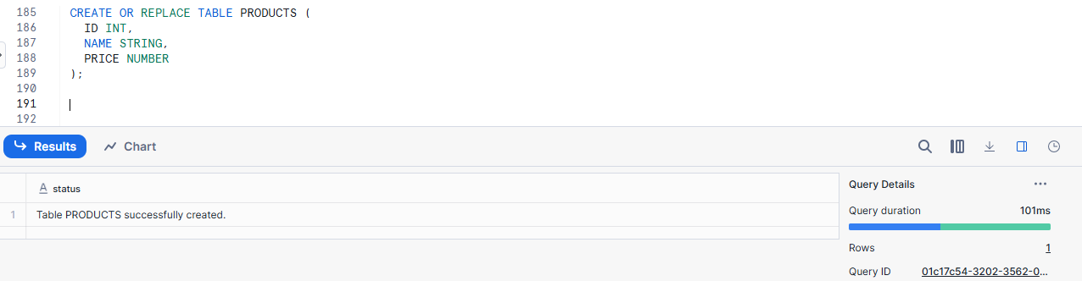
Insert Data
INSERT INTO PRODUCTS VALUES
(1, 'Pen', 10),
(2, 'Book', 50),
(3, 'Bag', 500);
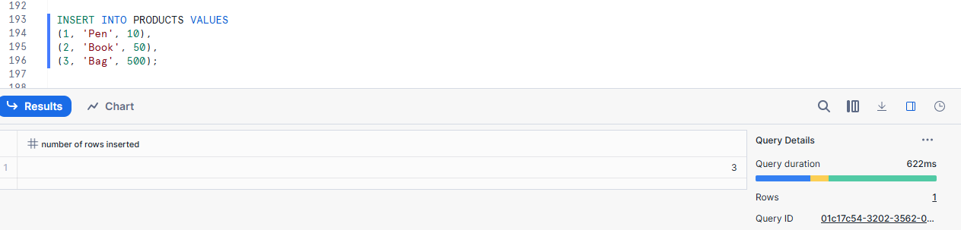
Query data (warehouse running)
SELECT * FROM PRODUCTS;
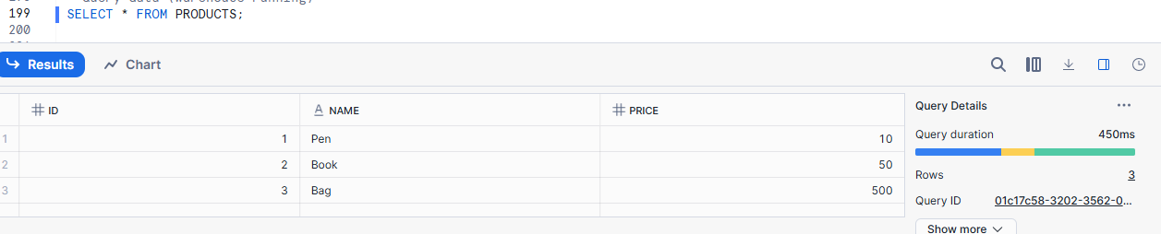
Suspend the warehouse
ALTER WAREHOUSE COMPUTE_WH SUSPEND;

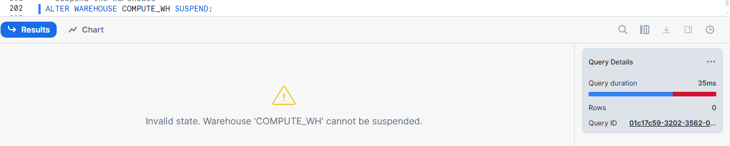
Resume the warehouse and query again
ALTER WAREHOUSE COMPUTE_WH RESUME;
SELECT * FROM PRODUCTS;
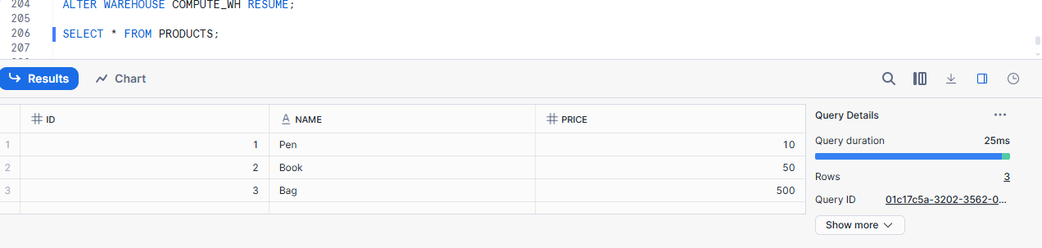
Same data appears again
Data never moved
Resize the warehouse
ALTER WAREHOUSE COMPUTE_WH SET WAREHOUSE_SIZE = 'LARGE';
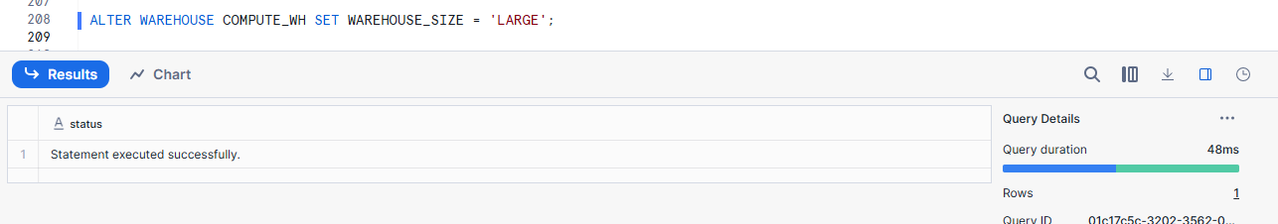
Run query again:
SELECT * FROM PRODUCTS;
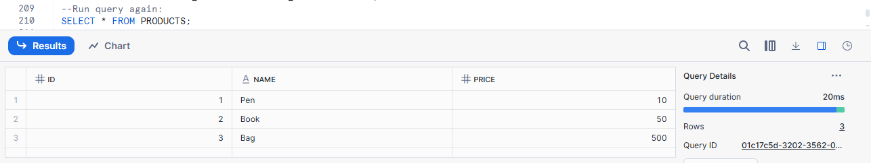
Query runs faster
Data is unchanged

14. Will Snowflake use Result Cache with non-deterministic functions like CURRENT_DATE? Why?
Practical:
Run a query with CURRENT_DATE, run it again, and show Result Cache is not used.

No. Snowflake does NOT use Result Cache for queries with non-deterministic functions (like CURRENT_DATE, CURRENT_TIMESTAMP) because the result can change every time the query runs.
Run a query with CURRENT_DATE
SELECT CURRENT_DATE;
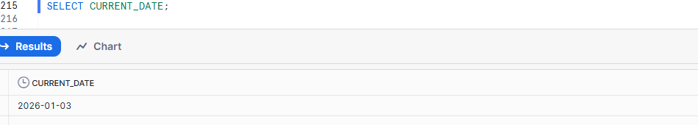
Query runs
Result is returned (today’s date)
Compute is used
Run the SAME query again
SELECT CURRENT_DATE;

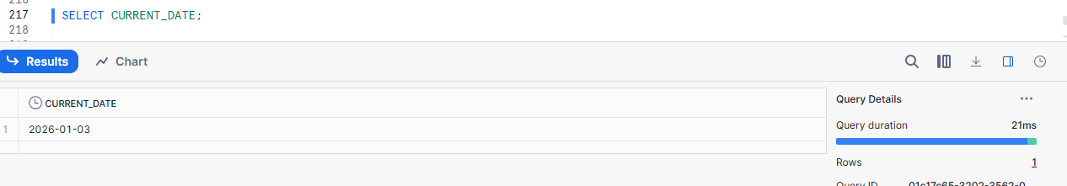
Query runs again
Compute is still used
Result Cache is NOT used

Compare with a deterministic query
Deterministic query
SELECT COUNT(*) FROM SALES;
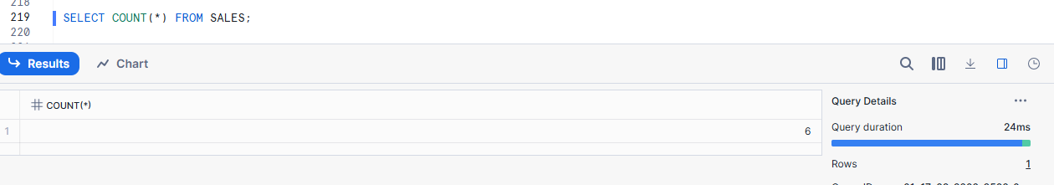
Non-deterministic query
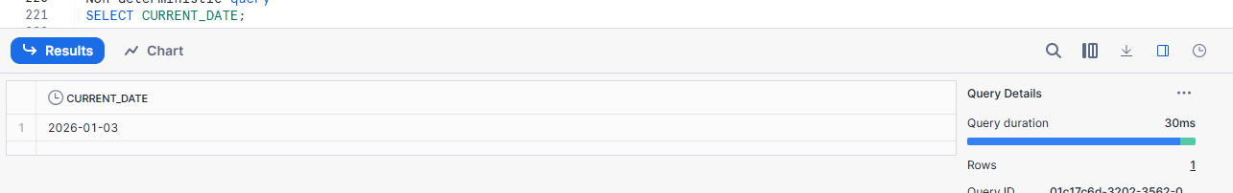

15. Summarize how Snowflake optimizes cost through architecture and caching.
Practical:
Explain how suspending warehouses when idle and reusing Result Cache save money.

Snowflake optimizes cost by separating storage and compute and by using caching, so you pay for compute only when queries run and avoid repeating the same work.
How Suspending Warehouses Saves Money
1 . Warehouse runs only when needed
A Virtual Warehouse is used only to run queries.
You are charged only while it is running.
2.Enable auto-suspend
CREATE OR REPLACE WAREHOUSE DEMO_WH
WAREHOUSE_SIZE = SMALL
AUTO_SUSPEND = 60
AUTO_RESUME = TRUE;
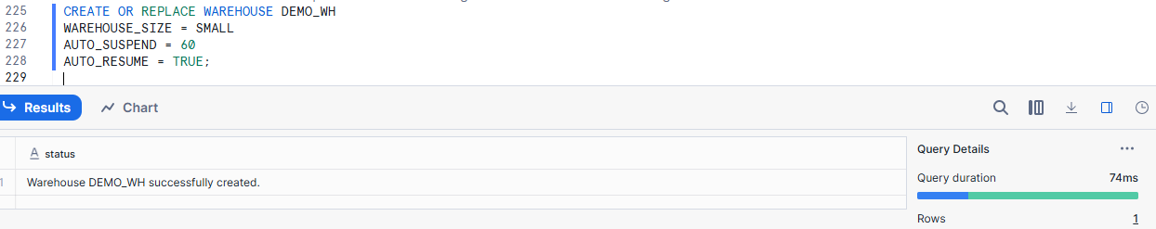
AUTO_SUSPEND = 60 Automatically stops after 60 seconds if no queries are running
AUTO_RESUME = TRUE Automatically starts again when you run a query.
3.Warehouse becomes idle
No queries are running
Warehouse is OFF
Cost = 0
not paying for idle compute
4.New query starts warehouse automatically
SELECT * FROM SALES;
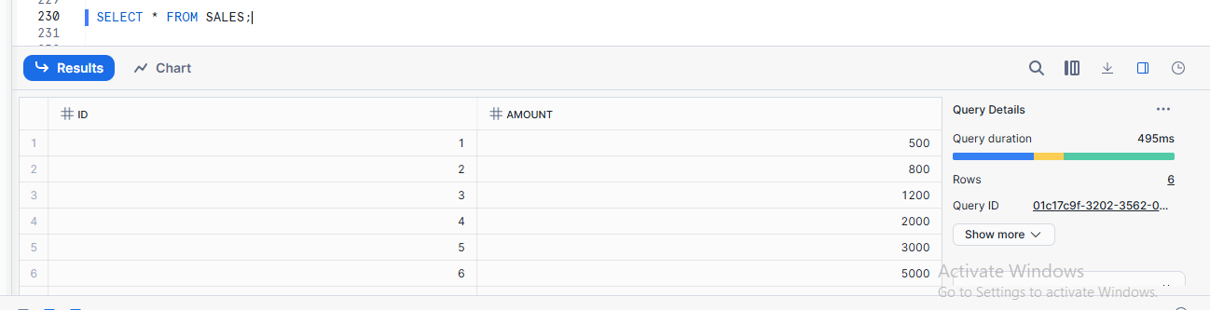
Warehouse runs
Data is processed
Result is stored in Result Cache
Compute cost is used
Run the same query again
SELECT COUNT(*) FROM SALES;

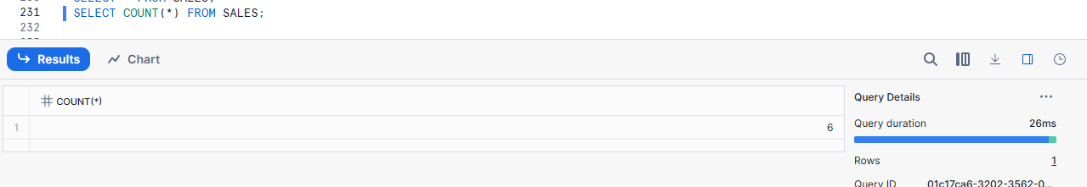

Snowflake returns result from Result Cache
No warehouse is used
No compute cost
Query runs instantly

